MQUAD DataVerse should be Dataverse
Terms and conditions (register page and Terms and Condition of Main Dataverse website)-Anjani-Done
Add below text with proper formatting
CONFIDENTIALITY: You will not attempt to identify individual study participants. You will not report information that could directly or by inference identify individual study participants.

ETHICS: You will obtain relevant approval prior to use the data.

ACCESS: Access to the data will be limited to the personnel named in the Data Application form. You will not distribute nor permit others to distribute any of the data to a person who is not listed. If new staff join the research team, you will submit an additional copy of Application.

SECURITY: You will store and analyze the data in a secure computing environment.

ACKNOWLEDGMENT: You will cite the data as the data source in all reports, presentations, and publications based on the data. Citations will appear in footnotes or in the reference section of any manuscripts.

PUBLICATIONS: At the conclusion of the proposed research, you will provide a copy of any publication or report based in whole or in part on the data to the author of the study/owner of the data.

LOSS OF PRIVILEGE TO USE DATA: If the data owner determines that you are in violation of the terms and conditions, you will destroy the data set, and any derivative data files, upon request.

Terms for Dataset(s) Standard but can be edit if client wants to add his own terms -anjani Done
Submission of the Application for Data Use is required to access the data from this study.

CONFIDENTIALITY: You will not attempt to identify individual study participants. You will not report information that could directly or by inference identify individual study participants.

ETHICS: You will obtain relevant approval prior to using the data.

ACCESS: Access to the data will be limited to the personnel named in the Data Application form. You will not distribute nor permit others to distribute any of the data to a person who is not listed. If new staff join the research team, you will submit an additional copy of Application.

SECURITY: You will store and analyze data in a secure computing environment.

ACKNOWLEDGMENT: You will cite the data as the data source in all reports, presentations, and publications based on the data. Citations will appear in footnotes or in the reference section of any manuscripts.

PUBLICATIONS: At the conclusion of the proposed research, you will provide a copy of any publication or report based in whole or in part on the data to <email of author or organization>.

LOSS OF PRIVILEGE TO USE DATA: If the <Name of the Data Organization> determines that you are in violation of these terms and conditions, you will destroy the data set, and any derivative data files, upon request.

Special Permissions To access data from this study, submit the Application for Data Use.

Main Home page of Dataverse - Khushboo-Done
Slide 1
A MQUAD Dataverse repository is a container for all dataset(s), files, and metadata. Presents the data using generic visual layout and custom statistical widget and enables data export for further analysis.
Slide 2
Collaboration enables two or more people, entities, or organizations to work together to complete a task or achieve a defined and common goal.

Show following counts below the content (dynamic)-Raju sir -Done
- Total number of dataset(s) uploaded
- Total number of collaboration created
- Number data types (quantitative/qualitative/others)
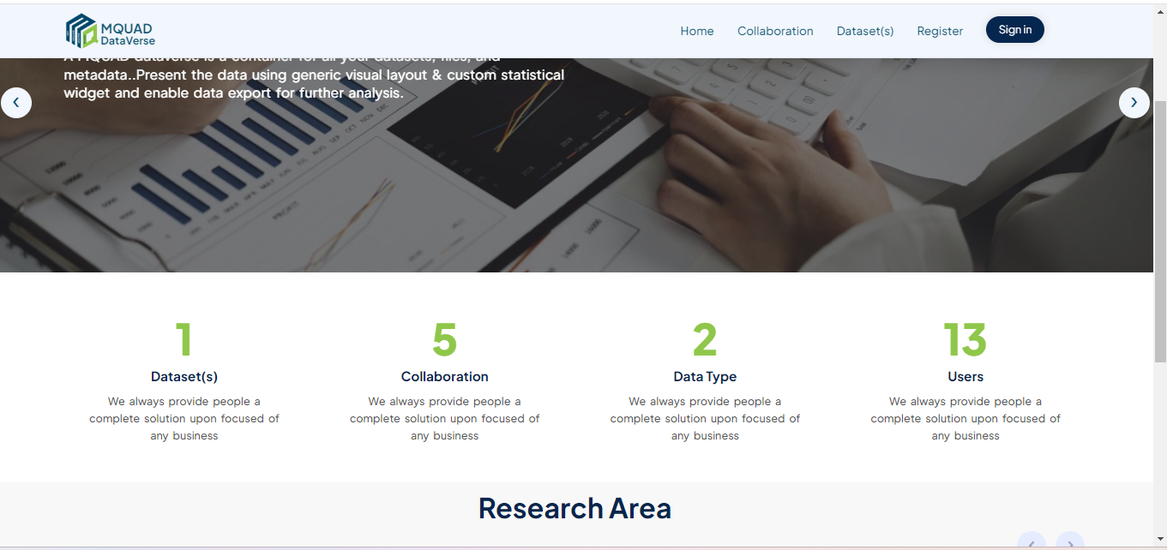

Show research areas (Will call from thematic areas)?

Research Area(s)-Khushboo

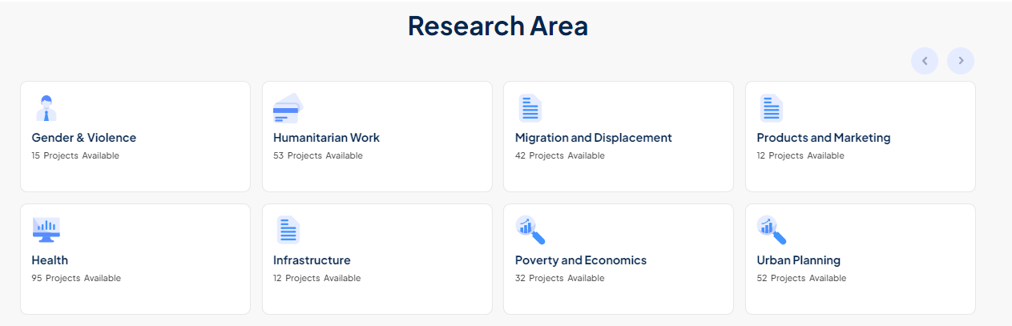
Collaboration tab page
Remove existing text (including Population Council and add below text-Khushboo-Done
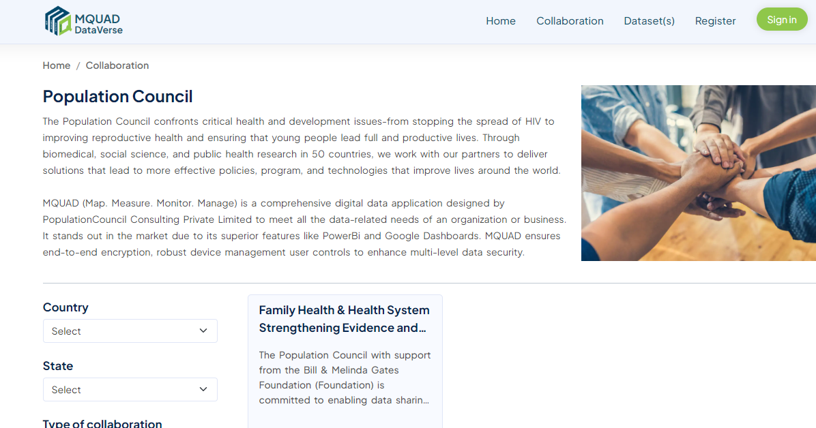

Collaboration is an essential aspect of success in any business. It often involves sharing knowledge, learning, and building consensus to foster innovation and solve complex problems. Effective collaboration requires not only appropriate tools and platforms but also a supportive culture that encourages open dialogue, mutual respect, and a shared vision. Collaborations can produce new goods and services, bring previously unfriendly organizations together, and create new and more powerful alliances. The degree of task interdependency or the division of labour within the collaborative goal can also create smaller groups of individuals working on subtasks.

Collaboration enables two or more people, entities, or organizations to work together to complete a task or achieve a defined and common goal.

Collaboration is a deeper level of working together that involves a shared vision, clear objectives, and a mutual understanding of each person’s role in achieving those goals.

Collaboration is a targeted, team-based activity and valued contributions in collaborative efforts lead to increased engagement, motivation, and commitment to shared goals.

Collaboration optimizes workflows, streamlines processes, and minimizes redundancies, leading to increased productivity. It is important to nurture a culture that naturally encourages and supports collaboration.

Collaboration box alignment -Anjani-Done
Latest added box should be first -Khushboo-Done

Left panel Type of study Study- Khushboo-Done

Home page of Dataset(s) -khushboo-Done
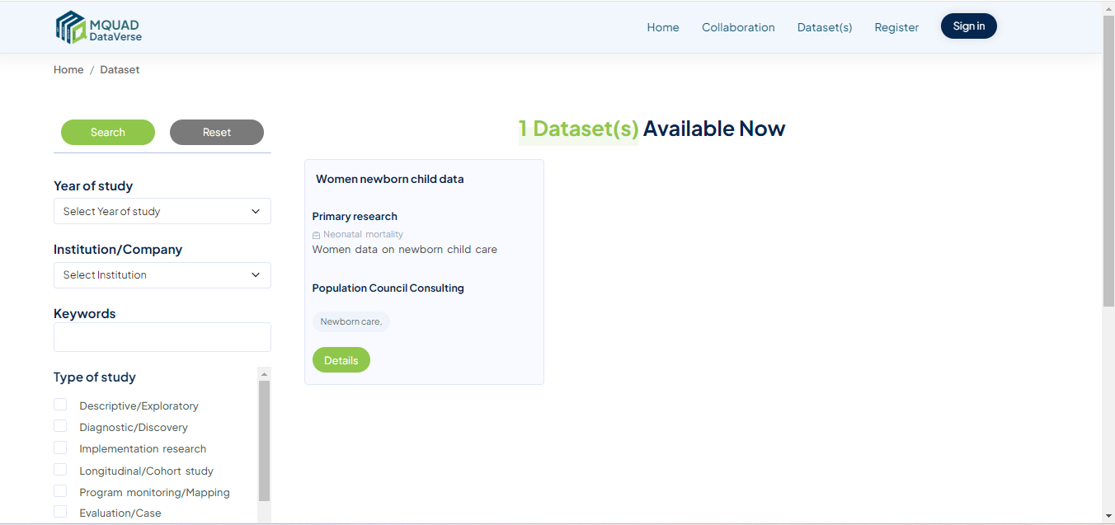

Change text to filter-Done

Year of study Study

Institution/Company Institution(s)/Company(s)

Keywords Keyword(s)

Type of study Study

Thematic Area Area(s)

Add below text and picture above the dataset(s) -Khusboo-Done

The Dataverse facilitates the creation of repositories to ensure that the data are high quality, properly documented and accessible. It allows researchers to deposit data in organized, curated, and citable networks. It helps data professionals find the most relevant data for any analytical or business purpose.

Comprehensive metadata to create an informative and searchable inventory (at study level and file level). Repository allows controlled access to data through permissions to ensure data security and compliance with privacy regulations.

Title
Description
Data type
Keyword(s)

View dataset without login
Published date should be when published on main dataverse-Done
Uploaded date is different-Done
Metadata should be with full information of dataset Done
Add Terms tab after Metadata tab-Done

Home page after login to be dynamic
Remove Study Types box if possible then link

Collaboration list page -Raju sir
Filter button (on right) aligned with breadcrumb to hide filter row
Dark Green when hover over collaboration title

Click on Read less , taking us to Conversation screen

Word spacing across all the pages -Anjani-Done
Line height 20px
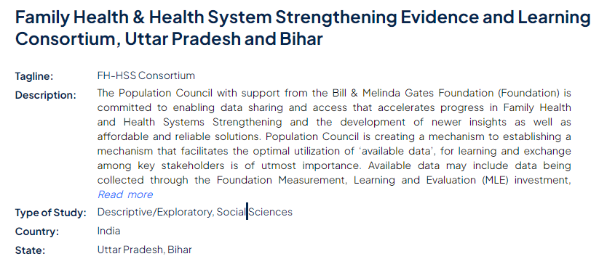

Edit project-Sandip
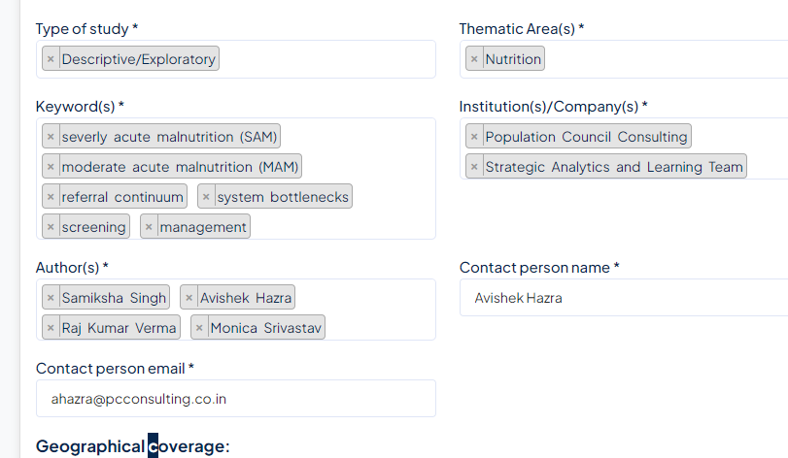

Description of all pages should be aligned full page -Anjani-Done
Permission for all documents- icon missing-Sandip
Working folder(s) – all pages
Check why we can upload exe. File in document tab -Done
Check why we can upload file without title-Done

Check Project detail (SAM and MAM) for conversation screen to correct main collaboration conversation screen -Sandip
Dialog box for
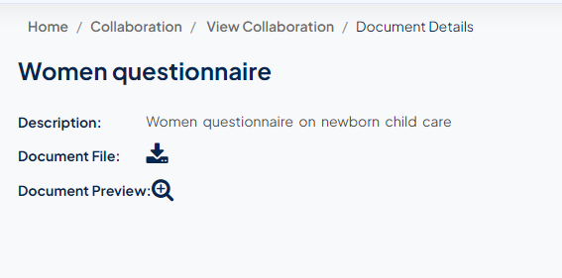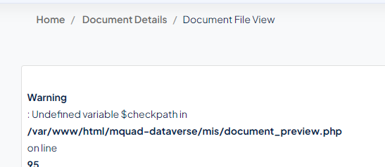
Check breadcrumb
Message to be corrected- Unassigned Permission -Sandip
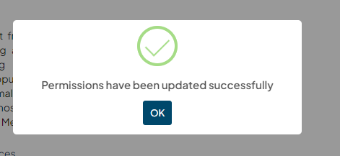

When permission unassigned then member should be listed again in Set permission table -Recheck Sandip
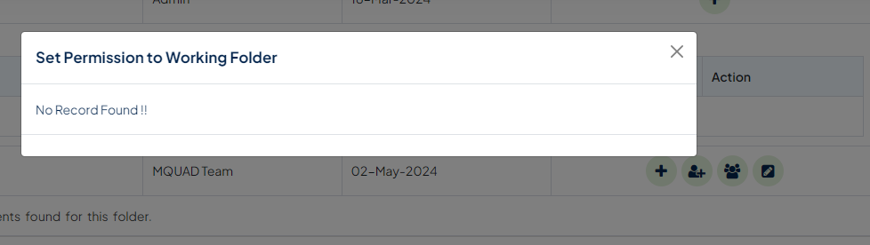
Check why Assigned member again automatically assigned- Recheck Sandip

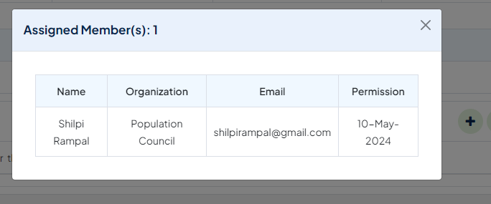
When unassigned from left box then automatically permission tick should be unticked Recheck Sandip

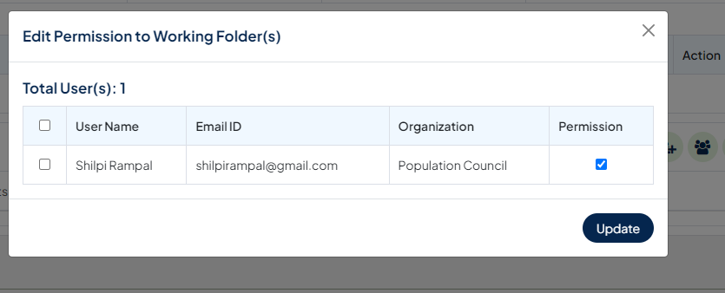
Working Folder not Working Folder(s)-Sandip
